**Test Case #1** **– Upload Project File**

Stage: 1, Upload Project File

Stage: 2, Listing the Uploaded files in the data table

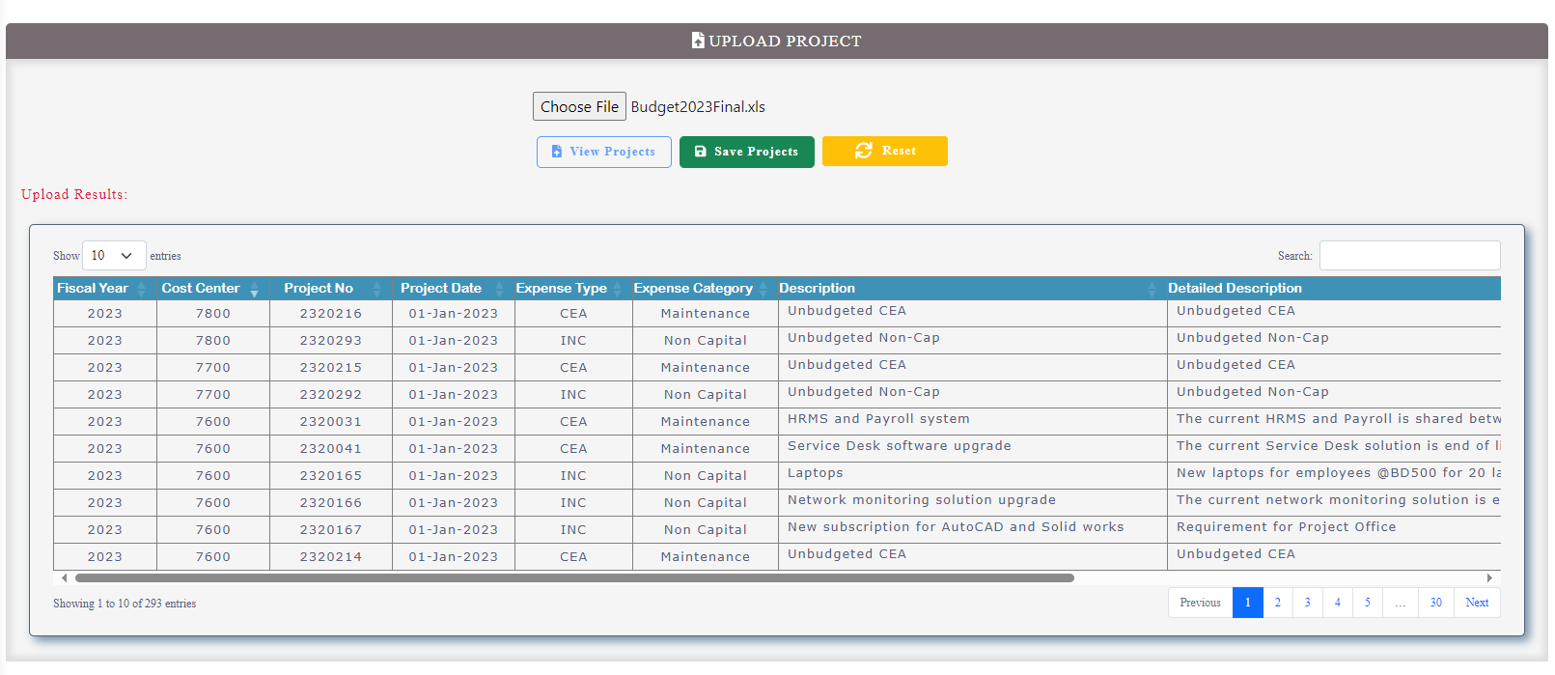

Stage: 3, Notification after the saving the Projects

Stage: 4, Listing the saved Project details in Project Enquiry Page

**Test Case #2 – Requisition Reassignment**

Stage: 1, Current status of the requisition no. 20230104

Stage: 2, Requisition No. 20230104 changing to the current approver Sreejith to Tafsir

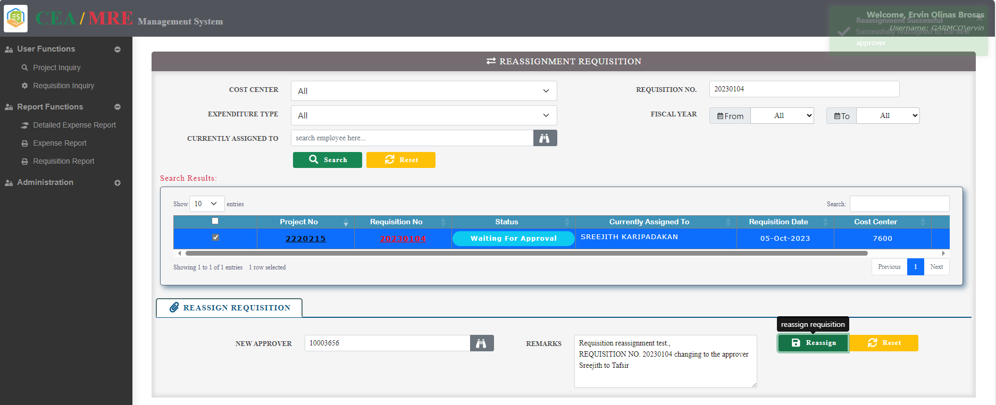

Stage: 3, Requisition No. 20230104 changed to the new approver Tafsir 10003656

Stage 4: Email notification is sent to the reassigned employee.

**Test Case #3 – Equipment Number Assignment**

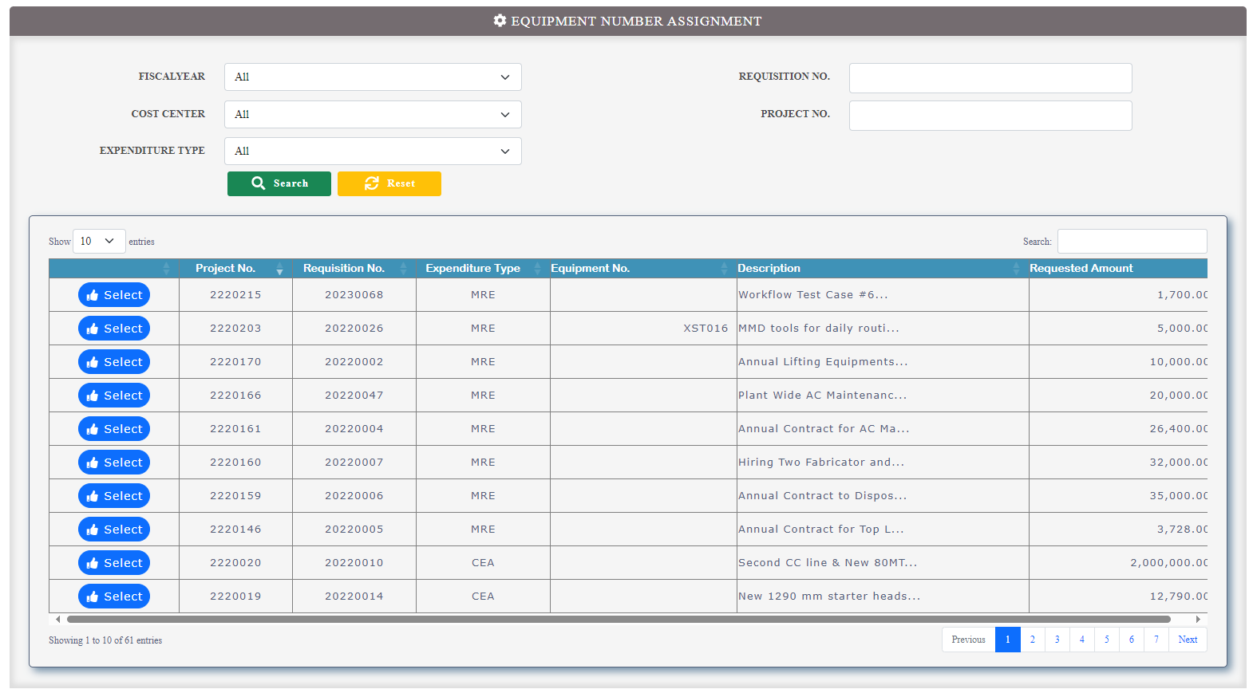

Stage: 1, Search with requisition number 20220002

Stage: 2, Select the requisition No. **20220002** and view the equipment number assignment details.

Stage: 3, Select the equipment and assign the equipment no. to the requisition.

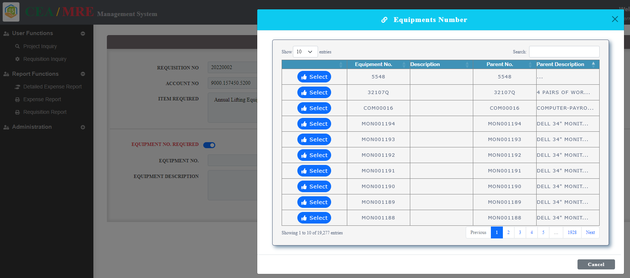

Stage: 4, Assigned the equipment no. to the requisition.

Equipment assignment Requisition number no longer available in the equipment number assignment list page.

Known issues:

1. After saving the equipment no. page is not redirecting the parent page (equipment number assignment form).
2. Stage 3, Equipment No. popup grid header not properly showing first time.

**Test Case #4 – Requisition Administration**

Stage: 1, Current status of the financial year 2022

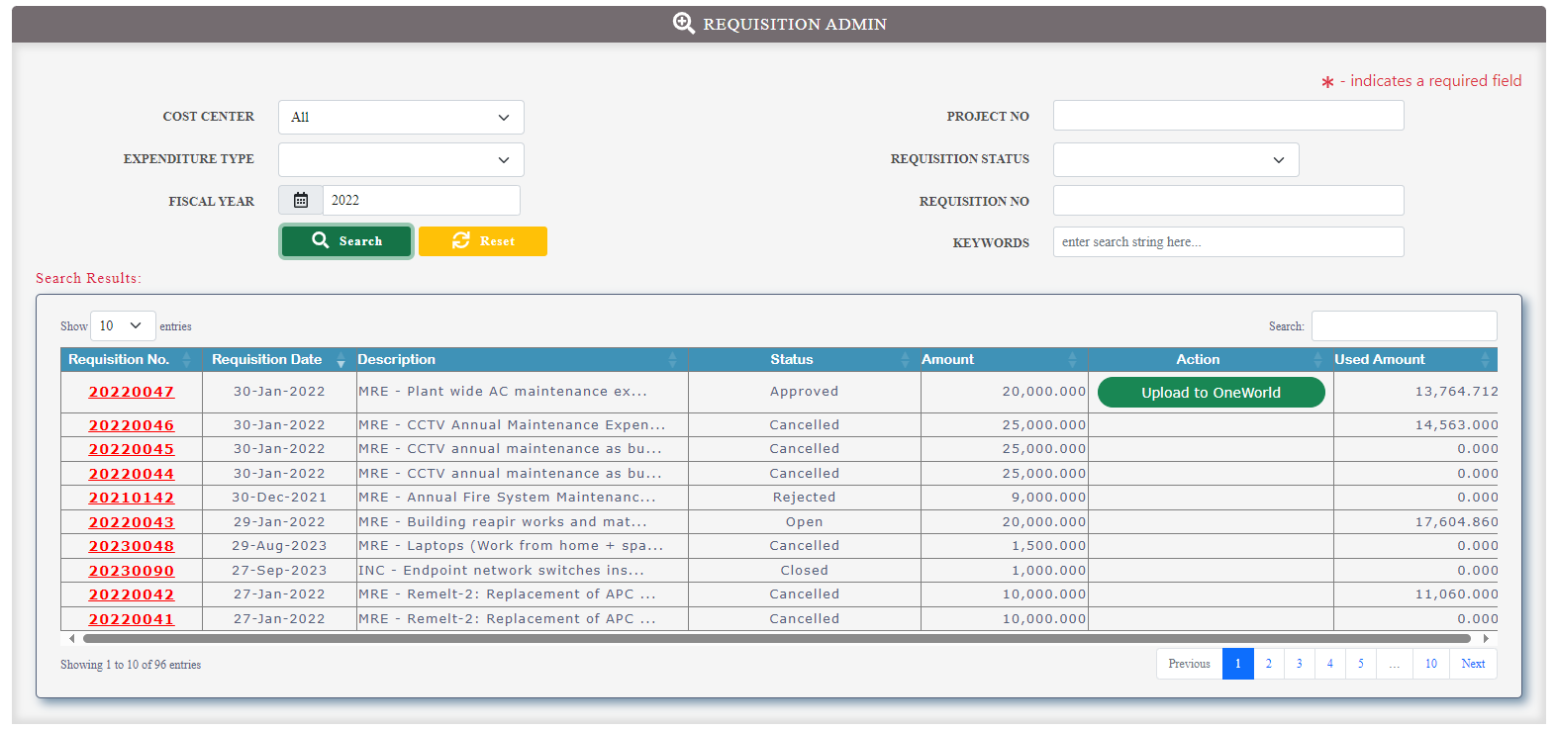

Stage: 2, Search with Requisition No. 20210029

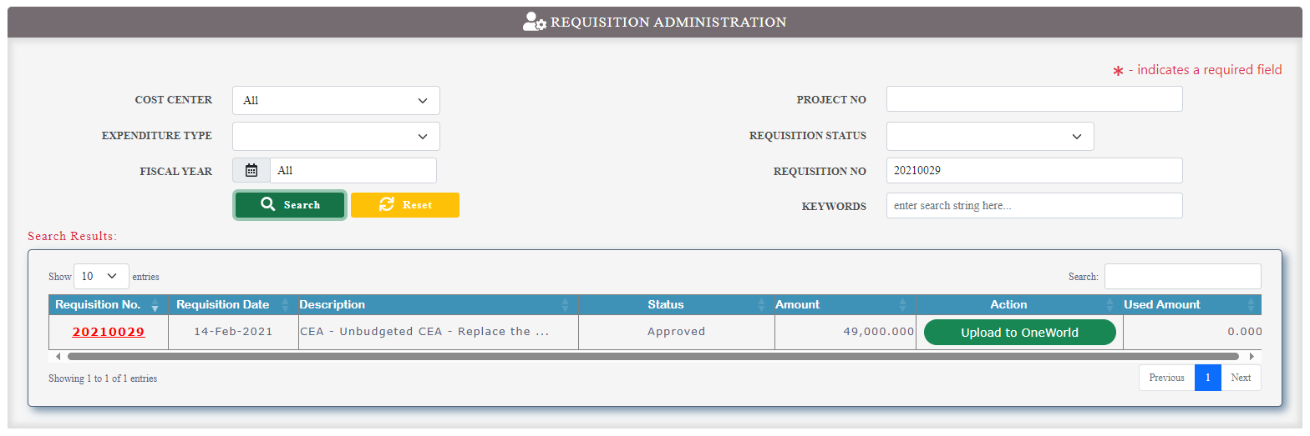

Stage:3 Click on Action Upload to Oneworld button email notification should be received to all the approvers.

Stage: 4, Requisition uploaded to oneworld status changed to Close Requistion.

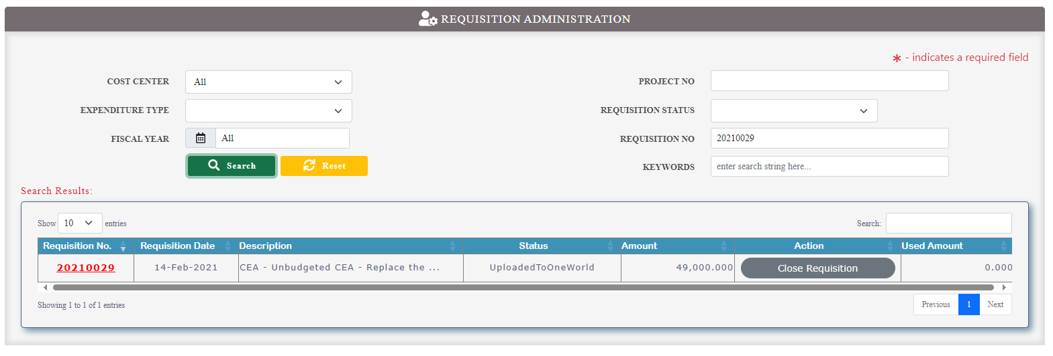

**Test Case #5 – Detailed Expense Report**

Stage: 1, Specify the search criteria.

1. Data Table showing the search result upto budget column
2. Datagrid showing the data upto Actual paid amount colum(end of the table).

**Test Case #6 – Expense Report**

Stage: 1, Specify the search criteria.

1. Data Table showing the search result up to budget column , Figure(#5-1)
2. Data Table showing the remaining columns up to Balance (end of the table) Figure(#5-2).

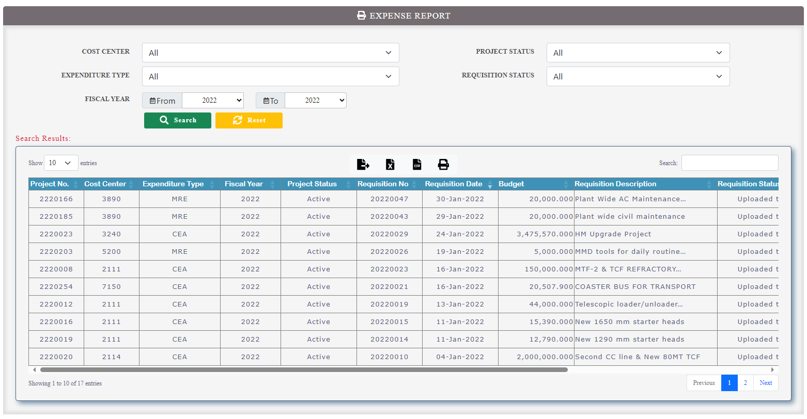

**Figure(#5-1)**

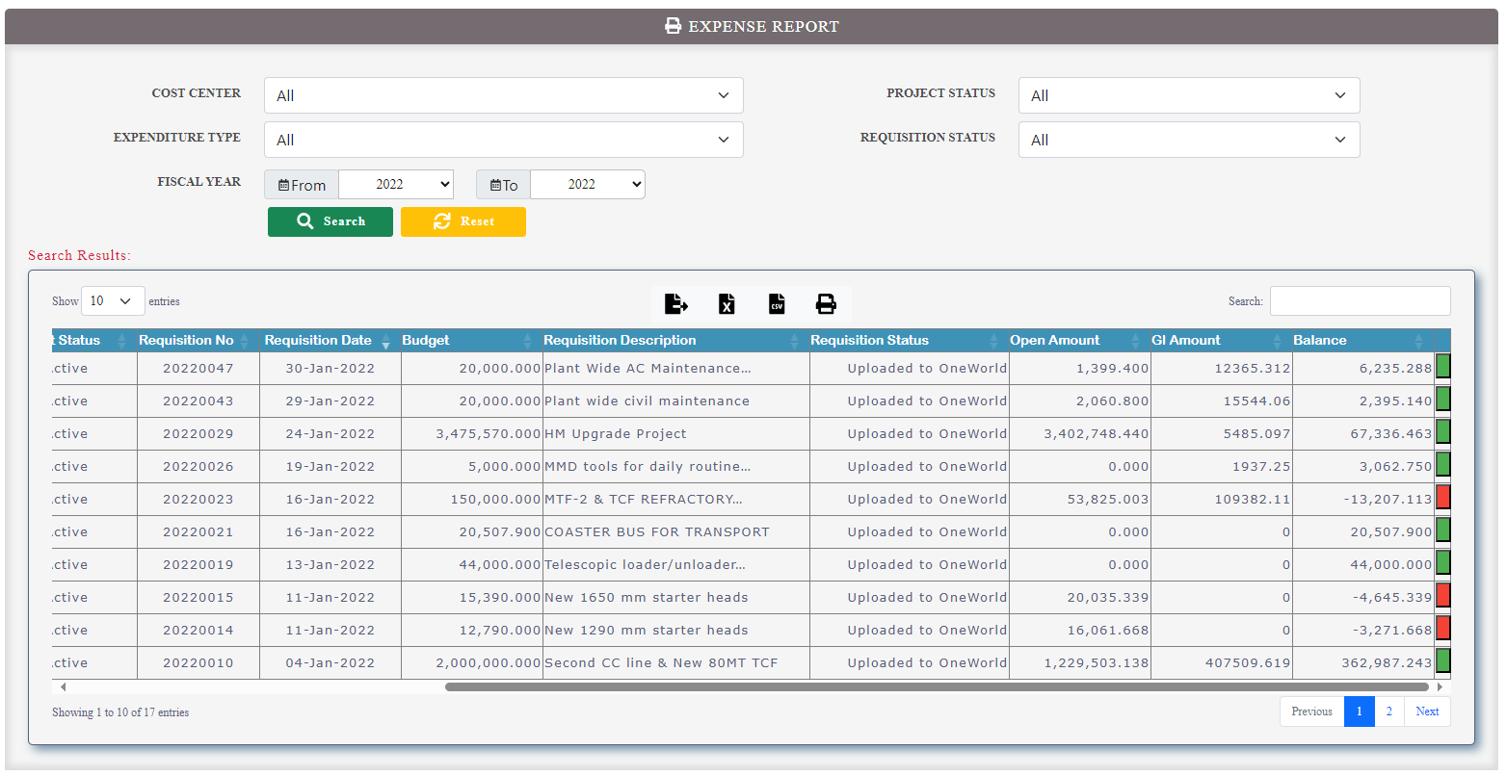

**Figure(#5-2)**

**Test Case #7 – Requisition Report**

Stage: 1, Specify the search criteria.

1. Data Table showing the search result.

